Game mechanic proposal – Review after Mentor’s feedback
2.6.2026

PLAYER MOVEMENT ACROSS SPACE

The player moves in a 2d space, top-down view, that represents the office they work in. The character is controlled by WASD keys
This mechanic can be used for a greater feel of control over the game and as a chance to break monotony of static UI screens. Can also be used as a smoother and more natural way to interact with the space and storyline

- Office Space: the player can interact with some of their colleagues a bit
  - Desk space (Action Point)
    - Here the player can access the main interface of the game, where they receive their tasks from the boss (as previously planned)
    - The player does the manual campaign building and information manipulation. (as previously planned)
  - AI machine space (Action Point)
    - The player will receive tasks that involve them walking over to a special AI machine. Here they will access special short minigames that are highly interactive (~Patrick’s idea)
  - Colleague interaction
    - The player will be prompted to go walk to a specific coworker and talk to them, here they will also get a feel for their campaigns impacts on people they know

- Break room: the player will be prompted to take their break; they must walk to the break room and while there they watch TV
  - TV: here the player gets a brief example of the impact their campaigns have on the real world and people they don’t know (in my opinion less on the nose than crude numbers)
    - They can get a report on some politician winning
    - Some small business going bankrupt etc.

References:
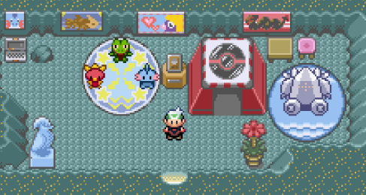
Pokemon Ruby, Emerald and Sapphire

